**Test Cases for ‘Yes Bank Site’**

Summary: Verify the GUI of the ‘Yes Bank Site’

Precondition: On the URL, ensure you are in the ‘<YesBank.html>’ link.

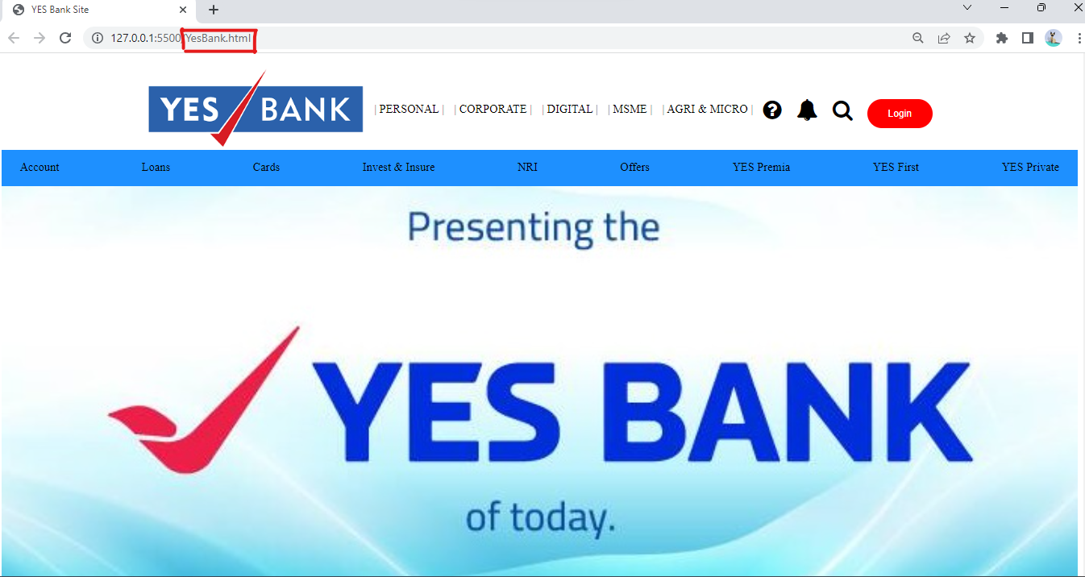

|  |  |
| --- | --- |
| **Test** | **Expected Result** |
| * Verify the ‘Yes Bank’ home page is visible. | * The Yes Bank page should be displayed |
| * Verify the navigation bar is visible. | * The ‘Yes Bank’ logo should be displayed on the left-hand side at the top of the page. * Following Tabs should be visible in the middle of the navigation bar.   PERSONAL  CORPORATE  DIGITAL  MASME  AGRI & MICRO   * Black colour icons and red colour ‘login’ button should be displayed on the right-hand side at the top of the page. |
| * Verify the tabs are visible. | * Following Tabs should be displayed on the blue background.   Account  Loans  Cards  Invest & Insure  NRI  Offer  Yes Premia  YES First  YES Private |
| * Verify the image is visible. | * The ‘Yes Bank’ image should be displayed in the middle of the page. |

Summary: Verify the GUI of the ‘Login’ Page for the Yes bank site.

Precondition:

On the Yes Bank home page, click on the ‘Login’ button.



On the URL, ensure you are in the ‘<index2.html>’ link.

The user Exists and navigates to the login page.

|  |  |
| --- | --- |
| **Test** | **Expected Result** |
| * Verify the Yes Bank ‘Login’ page is visible. | * The Yes Bank ‘Login’ page should be displayed. |
| * Verify the background. | * The background should be blue in colour. |
| * Verify the Yes bank logo is visible. | * The Yes Bank logo should be displayed on top of the page. |
| * Verify the text is visible. | * The following text should be displayed.   Have an Account?  Login |
| * Verify the text boxes are visible. | * The following text boxes should be displayed.   ‘Username’  ‘Password’ |
| * Verify the login button is visible. | * The ‘Login’ button should be displayed. |
| * Verify the checkbox is visible. | * The Remember Me check box should be displayed. |
| * Verify the text is visible. | * The following text should be displayed.   ‘Not Registered with NetBanking?’ |
| * Verify the link is visible. | * The ‘Register Here’ link should be displayed. |

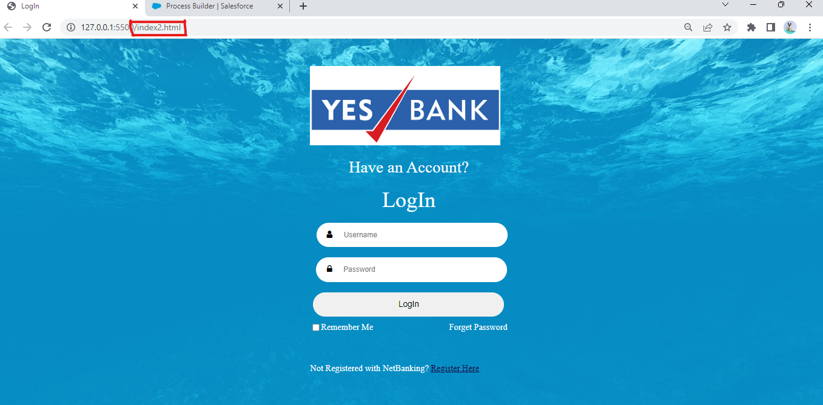

Summary: Verify the GUI of the ‘Registration Form’ Page for the Yes bank site.

Precondition:

On the login page, click on the ‘Register Here’ link.

On the URL, ensure you are in the ‘[index3.html](index2.html)’ link.

The user Exists and navigates to the login page.

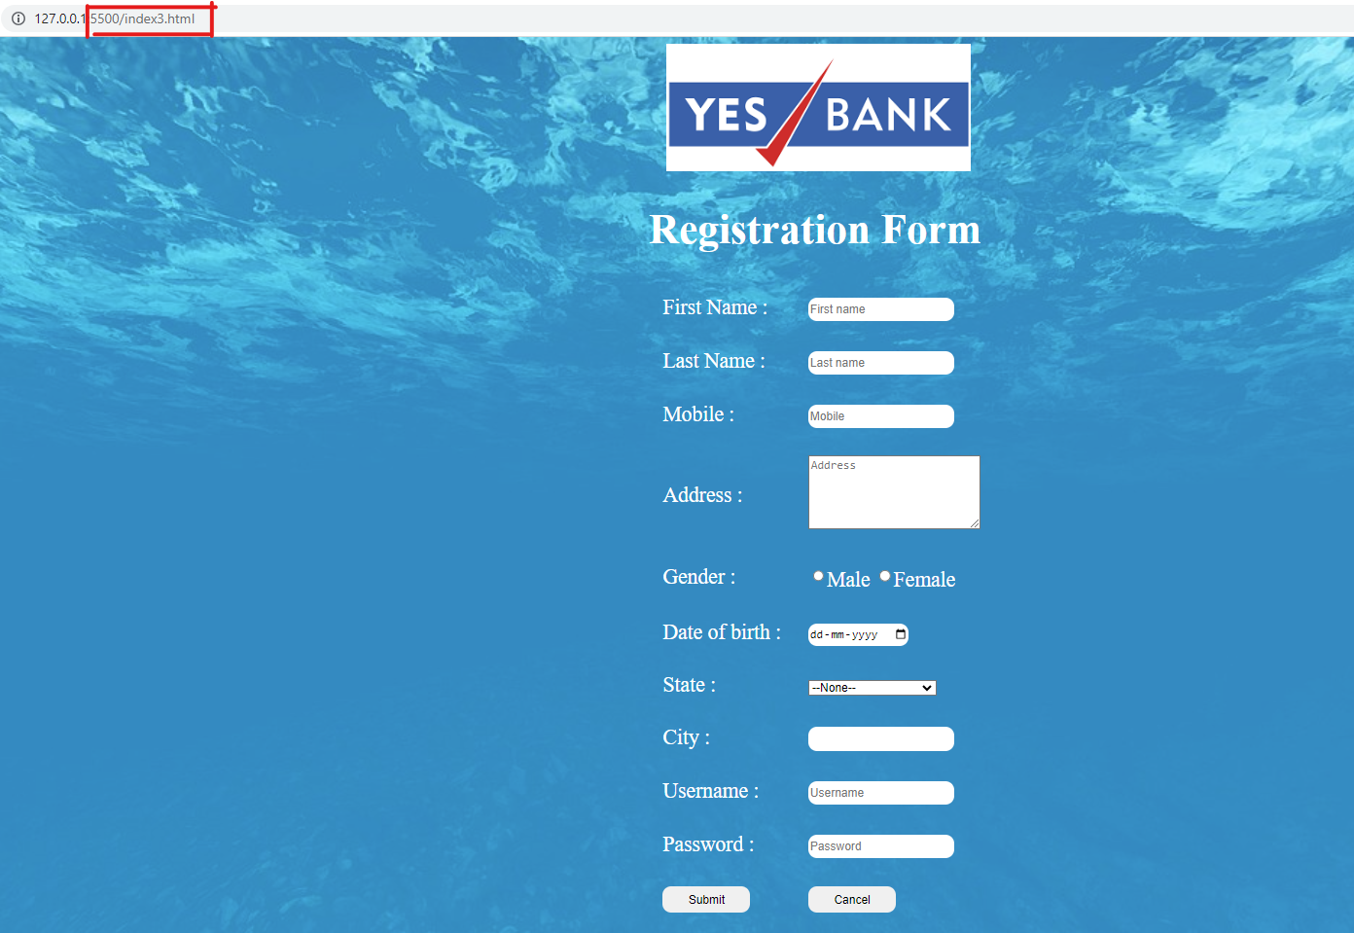

|  |  |
| --- | --- |
| **Test** | **Expected Result** |
| * Verify the Yes Bank ‘Registration’ page is visible. | * The Yes Bank ‘Registration’ page should be displayed. |
| * Verify the background. | * The background should be blue in colour. |
| * Verify the Yes bank logo is visible. | * The Yes Bank logo should be displayed on top of the page. |
| * Verify the text boxes are visible. | * The following text boxes should be displayed.   ‘First Name’  ‘Last Name’  ‘Mobile’  ‘Address’  ‘Gender’  ‘Date of Birth’  ‘State’  ‘City’  ‘Username’  ‘Password’ |
| * Verify the buttons are visible. | * The following buttons should be displayed.   ‘Submit’  ‘Cancel’ |